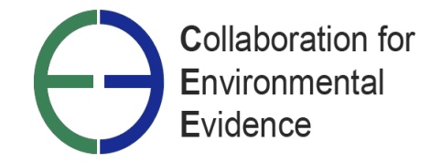

TRUSTEES

Highly motivated volunteers are sought to join the CEE Board.

A role that offers the opportunity to become involved in a global environmental initiative.

The Collaboration for Environmental Evidence (CEE) is a world leader in the promotion of ‘evidence-based practice’ in environmental management. Established in 2007, with charitable status in the UK, CEE is a global network of people who produce syntheses (systematic reviews) of the best available scientific evidence to inform decision makers on issues of importance to the environmental sector. CEE holds an open-access library of systematic reviews, provides guidelines and standards for their conduct and an open-access journal for their publication and the scientific development of the methodology. The development of CEE to date has been undertaken entirely through voluntary effort. New Trustees are sought to join with the Board of Trustees to help guide CEE towards achieving its mission and a key role would be to seek resources to enable CEE to establish a paid staff and thus achieve a ‘step change’ in reach and impact. You would need to be able to make a commitment to CEE and devote the necessary time, have strategic vision, independent judgement, an ability to think creatively and a willingness to take an active role in fund-raising. We are currently seeking candidates to fill the following positions;

- Chair-elect of the Board
- Treasurer

Ideally, the new trustees will have skills and experience in one or more of the following areas:
- fund-raising/resource investigation
- charity management and charity law
- accountancy, with experience of the charity sector
We are particularly keen to achieve a more diverse board of trustees, and we welcome applications from all sections of the international community.
An induction into CEE’s work will be provided. You will be expected to contribute roughly 6-12 days of your time per year and to attend up to three meetings per year (most of these may be conducted using telephone, skype or video conferencing).

The role description and application form are available on request to: admin@environmentalevidence.org . The CEE Constitution and other information is available on the CEE website at http://www.environmentalevidence.org/Resources.html. For an informal discussion about the role of Trustee, contact the Chair, Professor Andrew S. Pullin (a.s.pullin@bangor.ac.uk).

Charity Commission Registration number 1157607

